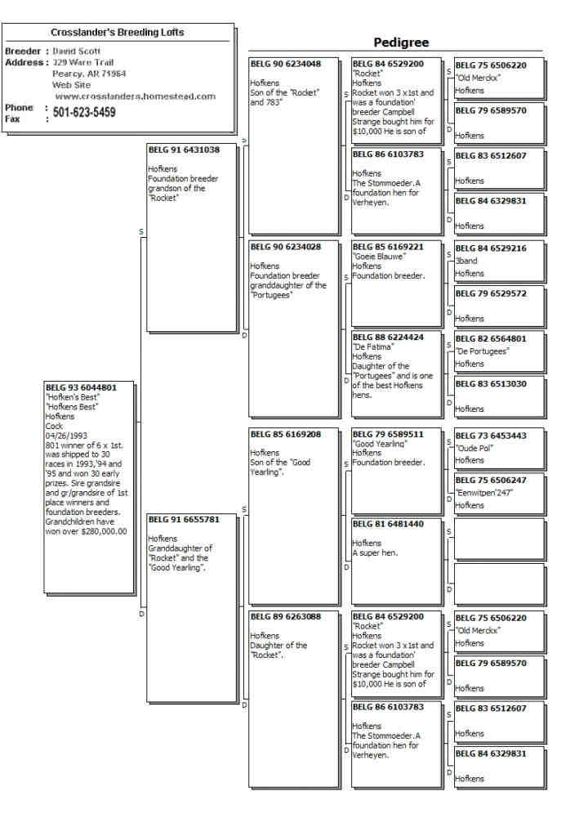

|  |
| --- |
| http://users.hky.com/donnas/public_html/wfl/wfllog.jpg |

Hofkens Best

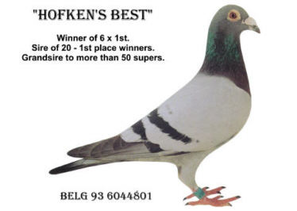

**The following is what Mike Ganus said about Hofken's Best.**

**Pure old Hofken's blood lines and a good one. He started off as a racer and destroyed his competition. He was shipped to 30 races in 1993, `94 and `95 and won 30 early prizes. Hofken's Best never missed and won 6 x 1st. He was put into the breeding loft where the family of winners took off. In the fancier's own words,**

**"Every youngster off 801 wins and breeds winners". The loft was taken over by childern and grandchildren with multiple 1st prizes and combine ace pigeons. I bought Hofken's Best in 1998. In 1999 he bred five youngsters for our Weyst/ Ganus team in Holland and all five youngsters were equal 1st place winners. All five were also in the top 20 Ace Youngsters in our club. This is unbelievable. Our first bird from National Orleans that placed in the top 100 national was off Hofken's Best.**

**We won 2 Combine 1st with a son and a daughter of Hofken's Best: 1st Morlincourt vs 1965 birds and 1st Etampes vs 1278 birds. Again in 2000, every youngster off Hofken's best was a super racer including our best youngster.**

**Hofken's Best parents were never raced. They were youngsters when they were purchased from Mr. Verheyen. They were both grandchildren of the Rocket**

**(Belg 6506200-75). Hofken's Best is a medium size, perfect body confirmation, very buoyant, strong breeding eye - a one in a billion breeding male. Very seldom do you see a bird of this quality and when I did I had to have him even though he was difficult to buy from his original owner.**

**The story below was told to me by Mike and a good friend of mine that was with Mike when he bought Hofken's Best and his original mate "The Super" (Belg 6221333-94) winner of 7 x 1st.**

**They went to Mr. Waters the owner of the pair to purchase birds bred from Verheyn stock. After looking at several birds Mike decided he wanted Hofken's best and his mate. A price was negotiated and the pair was bought, as Mr. Waters brought the pair to the car they noticed that  he had tears running down his face. It was difficult for Mike to take the pair after seeing this, but both parties were happy with the price.**

**Above you read about what the birds did for Mike in Holland. In the US grandchildren of Hofken's Best have won over $288,000.00, yes $288,000.00 in money races in the last three years. From the ones that we have tested, there are multiple 1st place winners, 1st place winners in the club, combine, and federation. There are now four generations of 1st place winners down from the "Stommoeder 76"**[**Story and information provided by David Scott   (Crosslander's Breeding Lofts)**](http://crosslanders.homestead.com/index.html)

**Children of Hofkens Best**

|  |  |  |
| --- | --- | --- |
| [CBL 999 2005](http://users.hky.com/donnas/public_html/wfl/999ped.html) | [FEH 81 2005](http://users.hky.com/donnas/public_html/wfl/hb81.html) | [CBL 850 2005](http://users.hky.com/donnas/public_html/wfl/hb850.html) |

**Grandchildren of Hofkens Best**

|  |  |  |
| --- | --- | --- |
| [TEXAS 2083 2004](http://users.hky.com/donnas/public_html/wfl/abeautped.html) | CBL 212 2006 | [CBL 669 2004](http://users.hky.com/donnas/public_html/wfl/669ped.html) |